Bug Report For **NISSAN Care SALES**

Incorrect data for Service Package Start date for AMC

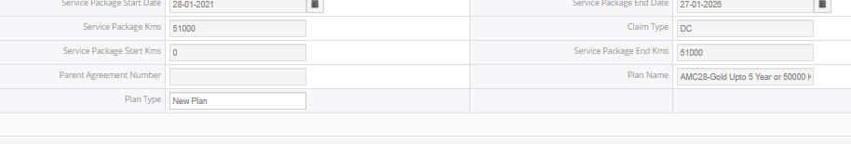

1.Job Card Validation and Space between in job card

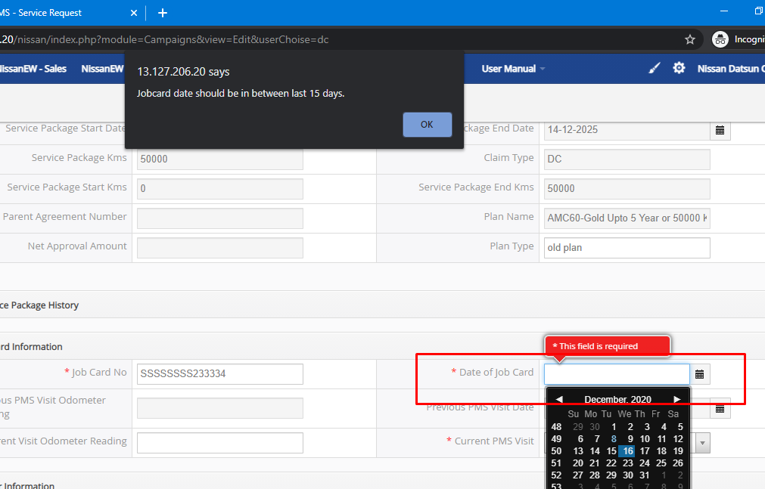

2.Date of job card is the date accepting greater than Service Package Start date

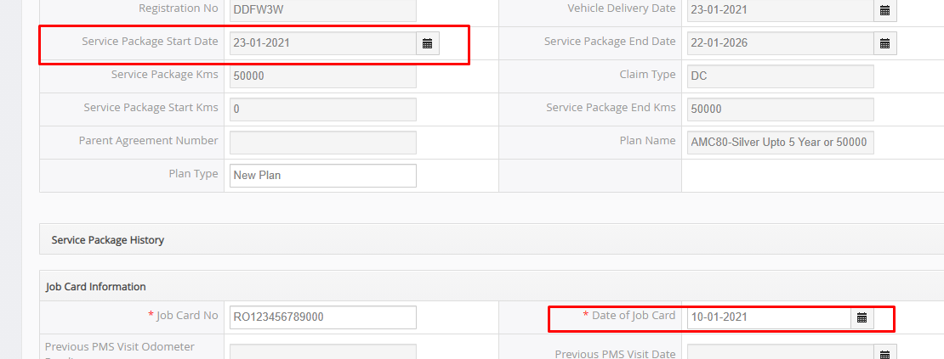

3.Plan Type is Editable



4.There should be space between name and surname



5.We can correct pop up correction **“Your Current Visit Odometer Reading should be greater than Previous visit Odometer Reading”**

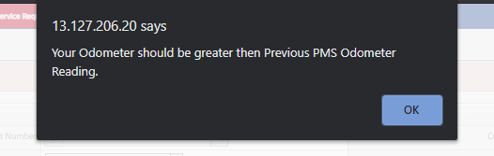

6.Two times of service plan is reflecting(**Service Done- 0k and 10K)**

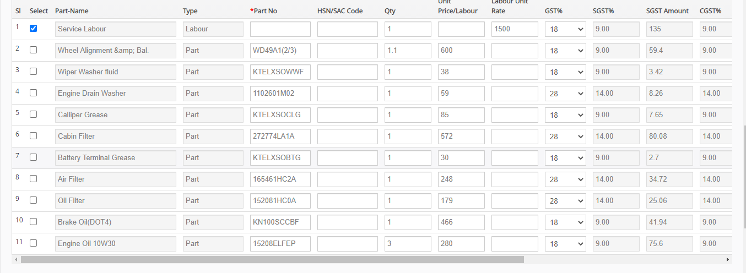

7.Date of job card is accepting Previous date of Previous PMS visit Date

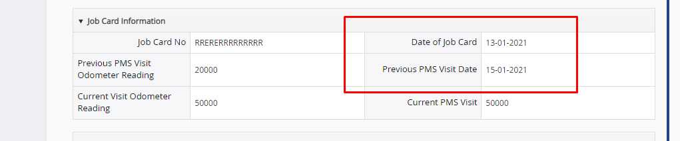

8.Current Visit Odometer Reading is accepting Back date of Previous PMS Visit Odometer Reading

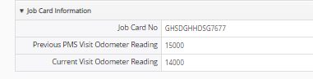

9.Current Visit Odometer Reading is accepting less than Service Package End Kms

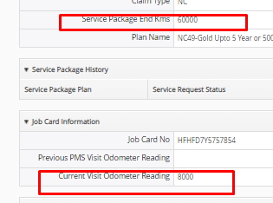

10. Sequencing of the document after saving the claim gets change.

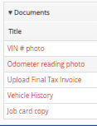---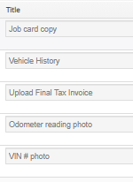

11. If user is entering the Current odometer reading 40000 then in SP History section showing 10000, 20000, and 30000 is lapsed

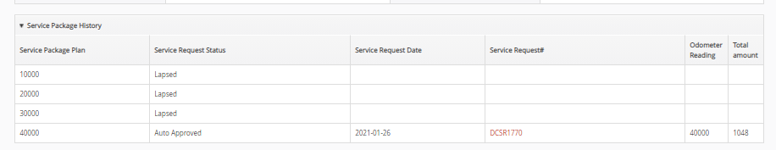

12.Invalid data is accepting for Part No and HSN/SAC Code(Should accept only the alphanumeric)

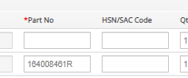

13.Grand Total price is coming while selecting the Agreement number, System is adding only the MRP not Labour(Grand Total Final Price Should be Zero while selecting the agreement, After selecting the Part No Grand Total Final Price Should comes accordinally)

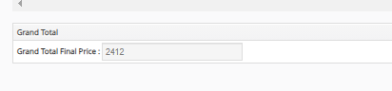

14.Created time Column name is different After Saving the Service Request

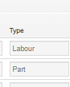-- 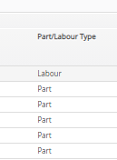

15.Total amount is coming wrong when user will again go for Service request(Calculating the total MRP only)

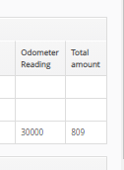

16.PMS reflecting two times

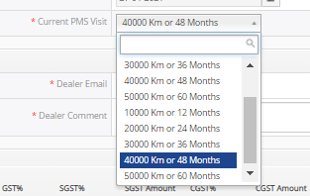

17.Two times of Grand Total in bold

